2020 September Board Meeting – Minutes

Monday, September 14, 2020, 4:00 PM – 6:00 PM – Microsoft Teams Meeting
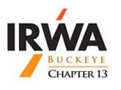

OFFICERS PRESENT
President | Kevin M. Jennings, RWA | X
President Elect | Rick Nichols | X
Vice President | Natalie R. Hess, RWA | X
Secretary | John C. Harrison, SR/WA | X
Assistant Secretary | Caitlynn Nagle | X
Treasurer | Jennifer D. Murray, SR/WA
Assistant Treasurer | Tracy M. Jones
International Director 1st Year | Cynthia Schaffer | X
International Director 2nd Year | Drew Gilmore | X
Membership Chair | Courtney J. Willis, RWP
Professional Development Chair | Shirley A. Oney, SR/WA, R/W-NAC
Education Chair | Beckie Shaw, RWA | X
Advisory Board (past President) | Kristina L. Breeding, SR/WA | X
Advisory Board (past President) | Mark R. Edgington | X
Advisory Board (past President) | Christine Deacon | X
Advisory Board (past President) | Michelle Agostinelli | X

Additional Attendees: Albano Mahilaj, Dan Bucan, Gerald Trout,

Call to Order: Kevin Jennings Date: 9/14/2020 Time: 4:04 PM

Finance Report –
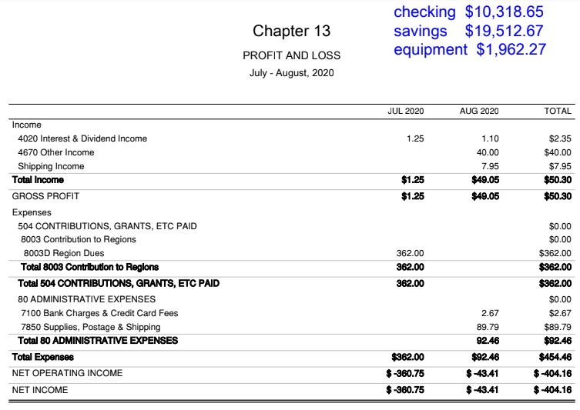

New Business

- Remaining 2020 Chapter Seminars all Virtual
  - September – Survey Day, Tuesday, September 15
    - Registration: mid 40s
    - 4 ½ CLE
  - October – Appraisal Day, Tuesday, October 20
    - date and presenters need to be finalized
  - November – Law Day, Tuesday, November 10
    - Final presenter being coordinated
  - 2021 Seminar Planning
    - Kevin Jennings to contact Jennifer Murray about following up with Der Dutchman about tentative 2021 Seminar dates, possibility of resuming in-person seminars.

- Region 5 Fall Forum being moved to Virtual – What platform is better?
  - Dan Bucan reported there will be a leadership call Wednesday. Microsoft Teams will be utilized
  - HQ is aware and will provide support
  - Fall Forum: after Wednesday’s call, a save the date email will be sent for the last week of October event.

- Region 5 Spring Forum being moved along to Illinois
  - Ohio to host 2021 Fall Forum
    - Discussion around possibility of holding event at Cedar Point the first weekend in October & inviting Region 4

- Region Information
  - International is understandably concerned about the San Antonio - 2021 International Education Conference, and possible company guidelines of attendees that would restrict attendance. International is planning to have both in-person and virtual capabilities for those interested.
  - Diversity Taskforce: no update to provide

- New Members
  - Kevin to follow up with Courtney Willis, Membership Chair

- Transportation Committee
  - Albano “Bano” Mahilaj volunteered to represent the chapter
  - Board to bring up committee during Tuesday’s seminar to attract additional participation
  - Bano offered to take on additional responsibilities to help coordinate future chapter Transportation Seminars

- IRWA Call for Awards – do we need to start working on these for 2021 (deadline believed to be end of January of calendar year)
  - Employer of the Year
  - Chapter of the Year
  - Young Professional of the Year
  - Website of the Year

International Director Report:
no update provided

Reports & Updates

Committees and members:
- Professional Development (2)
Chair: Shirley Oney oneys@bceo.org
Member:
Member:
Action Items/Comments:
- Debra Wheeler – Approved – RWP 8/21
- Eric Chianese – Approved – RWA 8/13
- Michelle Agostinelli – application pending – RWP

- Cleveland 2022
Co-Chairs: Dan Bucan and Kristina Breeding
Action Items/Comments:
- logo draft, review, rank & select
- Destination CLE – limited staffing currently, but a call is scheduled. Events at the convention center are not being scheduled for 2021 with it currently closed.
- Sponsorship Levels – Dan will get information out to the board
- Dan and Jade are planning to talk soon to discuss responsibilities of International and the chapter.

- Education (3)
Chair: Beckie Shaw rshaw@nisource.com
Member: Andy Glassmeyer andrew.glassmeyer@duke‐energy.com
Member: Gerald Tout gtout@martin-woodappraisal.com
Member: Kate Mensi kmensi@nisource.com
Upcoming Events:
- Beckie attended the virtual education seminar
  - to get an email out about chapter membership attendance
  - nothing currently planned for 2021, but can advise HQ of chapter’s interest in possible courses

- Membership & Public Relations (2)
Chair: Courtney Willis courtneywillis@nisource.com
Member: Christine Deacon cdeacon@opc-ohio.com
Action Items/Comments: no update/nothing provided

- Public Relations
Chair: Tom Schaffer tschaffer@aep.com
Action Items/Comments: no update/nothing provided

- Special Awards (Vice President)
Chair: Natalie Hess Natalie.Hess@duke-energy.com
Action Items/Comments: no update/nothing provided

- Meeting Arrangements and Registrations (Assistant Treasurer)
Chair: Jennifer Murray jennmurraysrwa@gmail.com
Member: Christine Handyside christine.handyside@percheronllc.com
Action Items/Comments: Kevin Jennings to follow up with Jennifer to get some tentative 2021 dates set up with Der Dutchman

- Social Media
Chair: Jennifer Murray jennmurraysrwa@gmail.com
Action Items/Comments: no update/nothing provided

- Young Professional
Chair: Judy Downs
Member:
Member:
Member:
Action Items/Comments: Currently being set up, getting feedback as to what the group would like to see from the chapter

- Surveying
Chair: Rick Nichols RNichols@mcgillsmithpunshon.com
Member:
Member: Mike Schutz mschutz@metroca.net
Action Items/Comments:
  - Tuesday’s Seminar:
    - Kevin Jennings to run, Rick to handle question & answer
    - A test run was conducted last week, and will do the same for the Appraisal Day seminar
    - Reminders – mute microphones, questions to be submitted through the Microsoft Teams chat feature, participants to enter their credential/license #

- Utilities
Chair: Eslie Shaw Eslie.Shaw@duke-energy.com
Member: Ryan Turner rturner@orcolan.com
Action Items/Comments: working on presenters & topics

- Continuing Education
Chair: Natalie Hess Natalie.Hess@duke-energy.com
Member:
Member:
Action Items/Comments: no update/nothing provided

- Valuation
Chair: Gerald Tout gtout@martin‐woodappraisal.com
Member:
Member:
Action Items/Comments: no update/nothing provided

- Website
Chair: Kevin Jennings Kevin.Jennings@duke-energy.com
Member: Angie Pick angie.pick@percheronllc.com Member: Mike Schutz mschutz@metroca.net Member: Albano Mahilaj amahilaj@dlz.com
Action Items/Comments: Website to be updated on Appraisal & Law seminar dates finalized

Meetings and Seminars
January 13, 2020 – Board Meeting
January 14, 2020 – Utility Day – Jenn sent out e-mail blasts and registrations are strong
March 9, 2020 – Board Meeting
March 10, 2020 – ODOT Day
April 24-25, 2020 - Region 5 Spring Forum, Green Bay, WI (virtual)
May 12, 2020 – Appraisal Day (POSTPONED)
June 21–24, 2020 - International Education Conference, Minneapolis, MN (CANCELLED)
July 13, 2020 – Planning Session (virtual)
September 14, 2020 – Board Meeting (virtual)
September 15, 2020 – Survey Day (virtual)
October 19, 2020 – Board Meeting (virtual)
October 20, 2020 – Appraisal Day (virtual) (RESCHEDULED DATE)
October 23-24, 2020 – Region 5 Fall Forum, Green Bay, WI
November 9, 2020 – Board Meeting (virtual)
November 10, 2020 – Law Day (virtual)
Other Chapter Christmas Parties

Meeting Adjourned by Kevin Jennings, 5:08 PM

