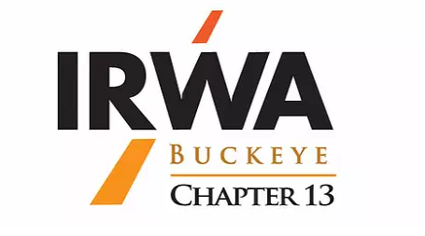
Region 4 & 5 Joint Fall Forum Ohio Sponsorship Opportunities
Oct 1 – 2, 2021

Region 4 & 5 fall forum is being hosted in Cleveland Ohio by Ohio Buckeye Chapter 13.

The fall forum is anticipated to have attendees from Ohio, Michigan, Kentucky, Indiana, Illinois, West Virginia, Pennsylvania, New York, New Jersey, Connecticut, Vermont, Rhode Island, Massachusetts, Maine, Delaware, Virginia, New York, New Hampshire, and Washington DC.

We have designed several levels of sponsorships to get your firm recognized during this event.

Each sponsorship level includes all items listed in levels below.
$2,500.00 or greater  Diamond | Acknowledgment during the Fall Forum and company Logo displayed.  Recognition on Chapter website Chapter website thru 2023.  15-minute presentation with PowerPoint during a Buckeye Seminar of choice
$1,000.00‐$1,499.00  Double Platinum | Acknowledgment during the Fall Forum and company Logo displayed.  Recognition and corporate website link on the Chapter website thru 2022.  10 -minute presentation at a Buckeye Seminar of choice in 2022
$500.00‐$999.00  Platinum | Acknowledgment during the Fall Forum and company Logo displayed.  Recognition and corporate website link on the Chapter website thru 2022.  5 -minute presentation at a Buckeye Seminar of choice in 2022
$500.00‐$999.00  Gold | Acknowledgment during the Fall Forum and company Logo displayed Platinum.  Recognition and corporate website link on the Chapter website through 2022.
$250.00‐$499.00  Silver | Acknowledgment during the Fall Forum and company Logo displayed Platinum.  Recognition and corporate website link on the Chapter website through 2021.

Mail sponsorship payments to IRWA Chapter 13 c/o Treasurer Jenn Murray, SR/WA (address) or pay by Square (details) For more information, please contact Jenn Murray, SR/WZ, jennmurraysrwa@gmail.com or Tracy Jones, tjones@ orcolan.com

is providing several levelaThis is a great opportunity to get your company Sponsoring opportinties at the IRWA’s Region 4 & 5 Forum.

Our has created several complementary sponsorship levels along with unique markeƟng opportuniƟes and special acƟviƟes. Flexible payment opƟons are available with final payment due May 2022. Do you have another groovy sponsorship idea? Custom sponsorships are available such as the Conference volunteer shirts, rocket car shuƩle, live concert performances, winery tour, museum day tours, The Annual Finnegan Fun Run, video presentaƟon and hospitality events. Contact us and we’ll create an opportunity to meet your needs. Mail sponsorship payments to IRWA Chapter 13 c/o Treasurer Jenn Murray, SR/WA: 86 Cherry Blossom RD SW Pataskala, OH 43062 or pay by Square: irwach13.square.site For more informaƟon, please contact Tina Breeding, SR/WA or Dan Bucan, SR/WA Each sponsorship level includes all items listed in levels below **Diamond and Double Platinum Sponsors listed as sponsor in 2022 Education Conference promotional video if sponsorship received by May 31, 2021**

Do you have another groovy sponsorship idea? Custom sponsorships are available such as the Conference volunteer shirts, rocket car shuƩle, live concert performances, winery tour, museum day tours, The Annual Finnegan Fun Run, video presentaƟon and hospitality events. Contact us and we’ll create an opportunity to meet your needs. Mail sponsorship payments to IRWA Chapter 13 c/o Treasurer Jenn Murray, SR/WA: 86 Cherry Blossom RD SW Pataskala, OH 43062 or pay by Square: irwach13.square.site For more informaƟon, please contact Tina Breeding, SR/WA or Dan Bucan, SR/WA

www.irwa13.org/cleveland‐2022

